For individuals who are only in the online program, analyze the relationship between donation frequency and whether OLP=1 across different age groups.

For example, in age group 1 (25-34), divide the population into two groups:

1. **Alumni who are only in the OLP program (OLP=1 and only has one degree).**
2. **Alumni who are not in the OLP program (OLP=0).**

Compare the donation frequency between these two groups using a histogram.

1. Compare the time difference between the online graduation year and first donation year (for donors) and plot the distribution.

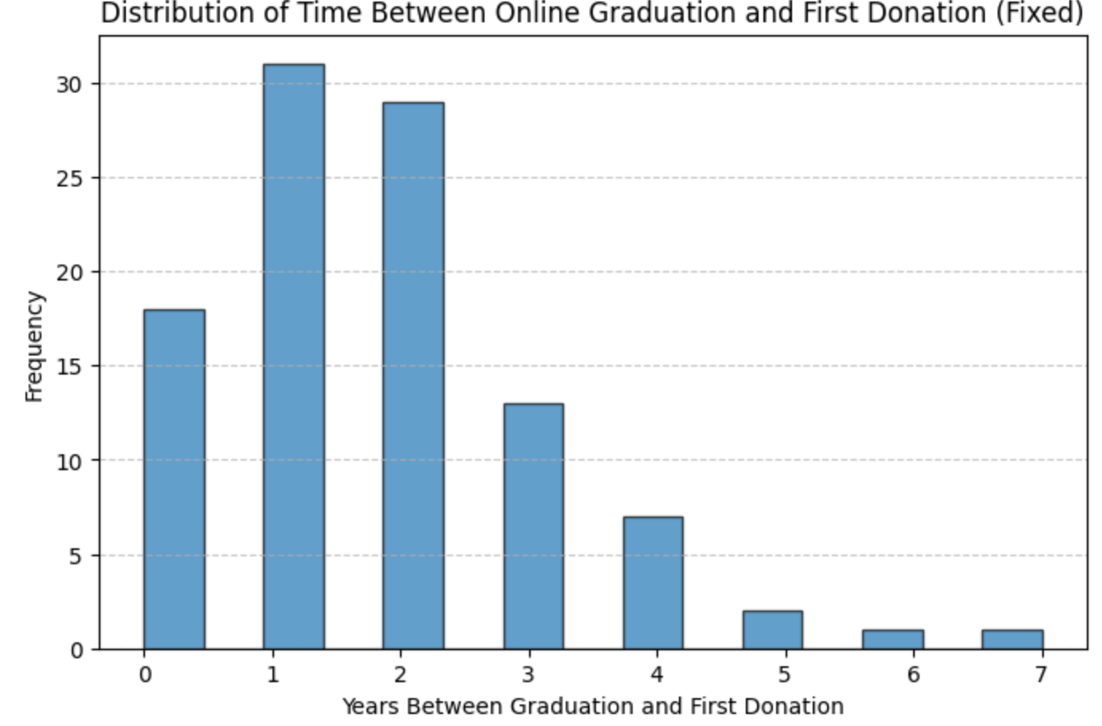

2. Analyze the correlation between OLP status (0 or 1) and donation likelihood for online program participants using correlation analysis and logistic regression.

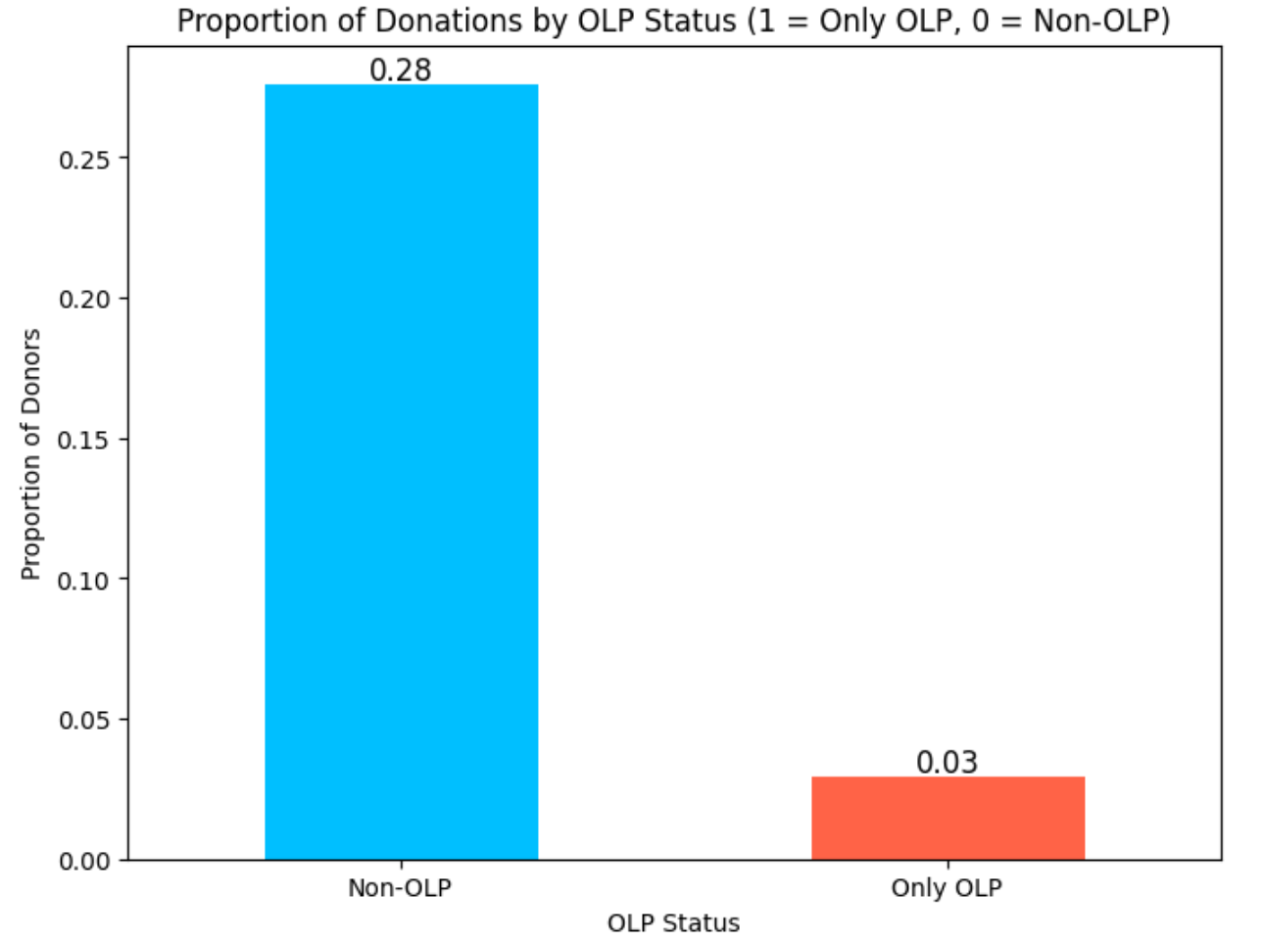

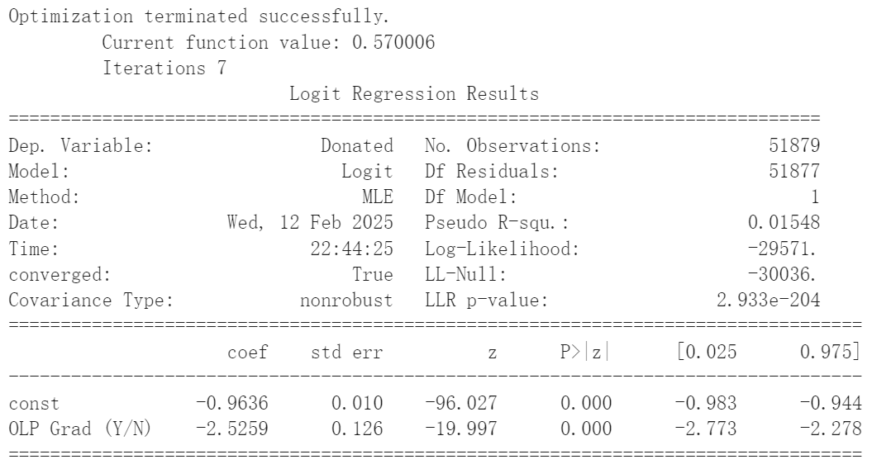

3. Compare the number of donations by OLP status across age groups (e.g., 25-34), using a histogram.

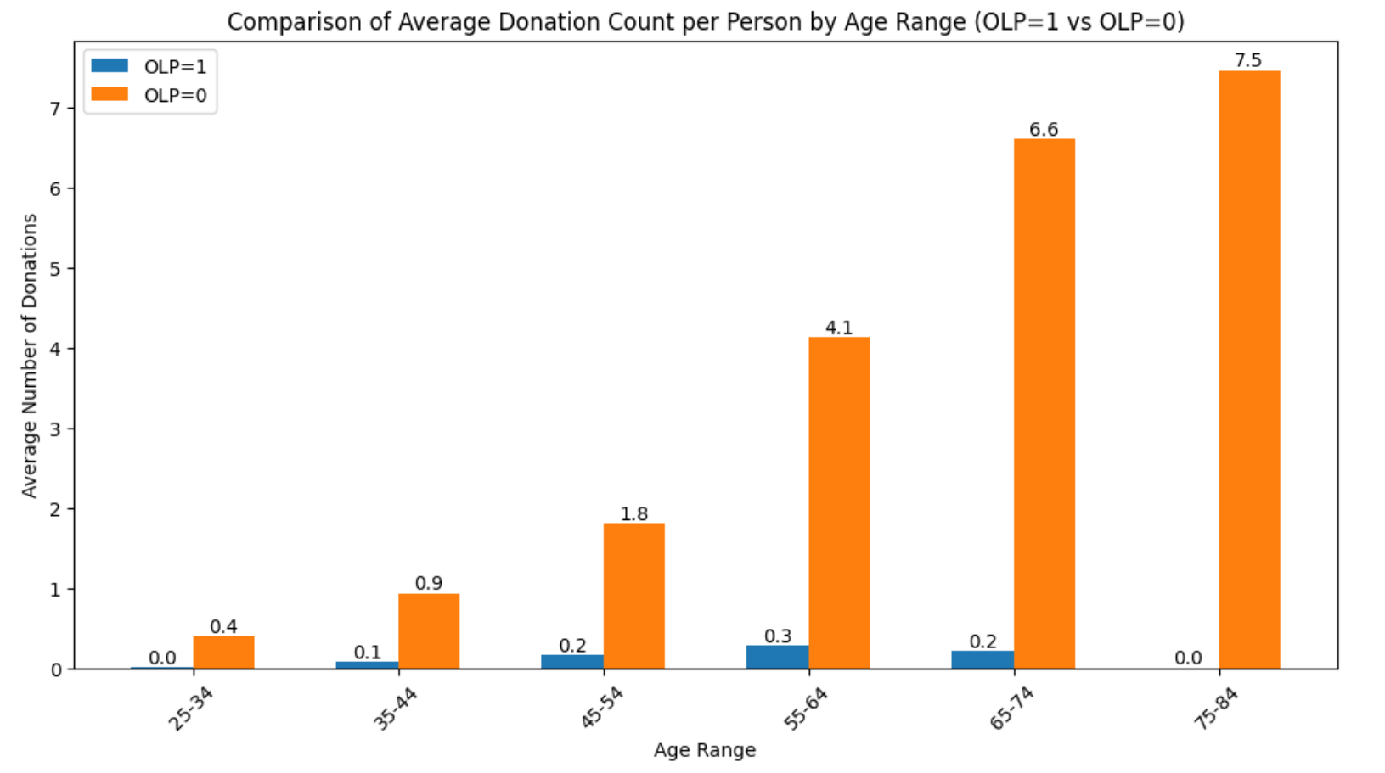

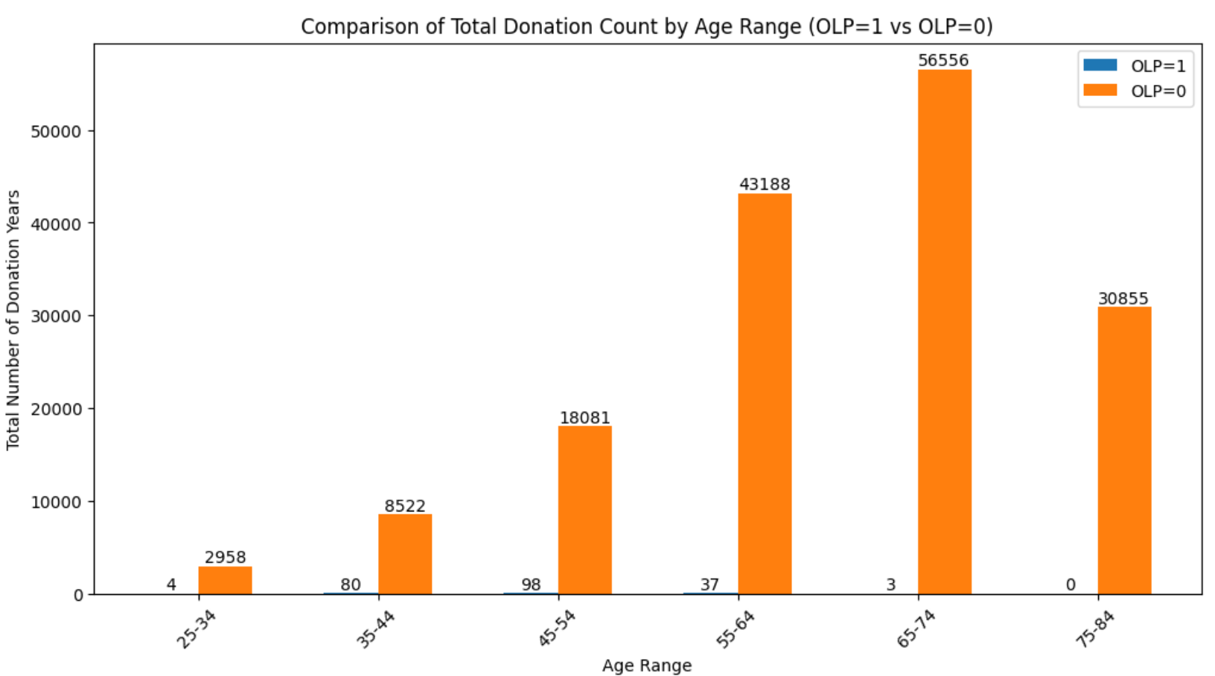

4. Compare the distribution of total donation amounts by OLP status across age groups.

